EX.NO:05 | JOB PORTAL MANAGEMENT SYSTEM
DATE:

1.AIM:
To develop a Job Portal Management System using HTML, Bootstrap, and JavaScript that allows recruiters to post job vacancies and applicants to apply for jobs with their resumes.
2.PROCEDURE:
Step 1: Create an HTML page and design the interface using Bootstrap for layout and styling.
Step 2: Develop a job posting form for recruiters to enter job title, company, location, and description.
Step 3 : Use JavaScript classes to manage job and applicant data.
Step 4 : Store job and applicant information using localStorage.
Step 5: Implement an Apply Job modal form for candidates to submit their details and upload resumes.
Step 6 : Display the list of available jobs and applied candidates dynamically on the webpage
3.PROGRAM SOURCE CODE :
Jobportal.html
<!DOCTYPE html>
<html lang="en">
<head>
<meta charset="UTF-8">
<title>Modern Job Portal</title>
<meta name="viewport" content="width=device-width, initial-scale=1">

<link href="https://cdn.jsdelivr.net/npm/bootstrap@5.3.2/dist/css/bootstrap.min.css" rel="stylesheet">
<style>
body {
background: linear-gradient(to right, #667eea, #764ba2);
color: #fff;
}
.sidebar {
background: rgba(0,0,0,0.4);
min-height: 100vh;
padding: 20px;
}
.content {
padding: 30px;
}
.card {
border-radius: 15px;
}
.btn-custom {
background: #ff7e5f;
border: none;
}
</style>
</head>

<body>

<div class="container-fluid">
<div class="row">

<!-- Sidebar -->
<div class="col-md-3 sidebar">
<h3>Recruiter Panel</h3>
<form id="jobForm">
<input type="text" id="title" class="form-control mb-2" placeholder="Job Title" required>
<input type="text" id="company" class="form-control mb-2" placeholder="Company" required>
<input type="text" id="location" class="form-control mb-2" placeholder="Location" required>
<textarea id="description" class="form-control mb-2" placeholder="Description" required></textarea>
<button class="btn btn-light w-100">Post Job</button>
</form>
</div>

<!-- Main Content -->
<div class="col-md-9 content">
<h2 class="mb-4">Available Jobs</h2>
<div class="row" id="jobList"></div>

<hr class="my-5">

<h2>Applied Candidates</h2>
<div class="row" id="applicantList"></div>
</div>

</div>
</div>

<!-- Apply Modal -->
<div class="modal fade" id="applyModal" tabindex="-1">
<div class="modal-dialog">
<div class="modal-content text-dark">
<div class="modal-header">
<h5 class="modal-title">Apply for Job</h5>
<button class="btn-close" data-bs-dismiss="modal"></button>
</div>
<div class="modal-body">
<form id="applyForm">
<input type="hidden" id="jobId">
<input type="text" id="applicantName" class="form-control mb-3" placeholder="Your Name" required>
<input type="email" id="applicantEmail" class="form-control mb-3" placeholder="Email" required>
<input type="file" id="resumeFile" class="form-control mb-3" accept=".pdf,.doc,.docx" required>
<button class="btn btn-primary w-100">Submit Application</button>
</form>
</div>
</div>
</div>
</div>

<script src="https://cdn.jsdelivr.net/npm/bootstrap@5.3.2/dist/js/bootstrap.bundle.min.js"></script>

<script>
class Job {
constructor(id, title, company, location, description) {
this.id = id;
this.title = title;
this.company = company;
this.location = location;
this.description = description;
}
}

class Applicant {
constructor(jobId, name, email, resumeName, resumeData) {
this.jobId = jobId;
this.name = name;
this.email = email;
this.resumeName = resumeName;
this.resumeData = resumeData;
}
}

let jobs = JSON.parse(localStorage.getItem("jobs")) || [];
let applicants = JSON.parse(localStorage.getItem("applicants")) || [];

const jobForm = document.getElementById("jobForm");
const jobList = document.getElementById("jobList");
const applicantList = document.getElementById("applicantList");

jobForm.addEventListener("submit", e => {
e.preventDefault();

const newJob = new Job(
Date.now(),
title.value,
company.value,
location.value,
description.value
);

jobs.push(newJob);
localStorage.setItem("jobs", JSON.stringify(jobs));
jobForm.reset();
displayJobs();
});

function displayJobs() {
jobList.innerHTML = "";

jobs.forEach(job => {
jobList.innerHTML += `
<div class="col-md-6 mb-4">
<div class="card p-3 text-dark shadow">
<h5>${job.title}</h5>
<p><b>${job.company}</b> | ${job.location}</p>
<p>${job.description}</p>
<button class="btn btn-success btn-sm"
onclick="openApplyModal(${job.id})">
Apply
</button>
</div>
</div>
`;
});
}

function openApplyModal(jobId) {
document.getElementById("jobId").value = jobId;
new bootstrap.Modal(document.getElementById("applyModal")).show();
}

document.getElementById("applyForm").addEventListener("submit", function(e){
e.preventDefault();

const jobId = parseInt(document.getElementById("jobId").value);
const name = applicantName.value;
const email = applicantEmail.value;
const file = resumeFile.files[0];

const reader = new FileReader();
reader.onload = function(event) {
const applicant = new Applicant(
jobId,
name,
email,
file.name,
event.target.result
);
applicants.push(applicant);
localStorage.setItem("applicants", JSON.stringify(applicants));

displayApplicants();
bootstrap.Modal.getInstance(document.getElementById("applyModal")).hide();
document.getElementById("applyForm").reset();
};

reader.readAsDataURL(file);
});

function displayApplicants() {
applicantList.innerHTML = "";

applicants.forEach(app => {
const job = jobs.find(j => j.id === app.jobId);

applicantList.innerHTML += `
<div class="col-md-6 mb-4">
<div class="card p-3 text-dark shadow">
<h5>${app.name}</h5>
<p>${app.email}</p>
<p><b>Applied For:</b> ${job ? job.title : ""}</p>
<a href="${app.resumeData}"
download="${app.resumeName}"
class="btn btn-primary btn-sm">
View Resume
</a>
</div>
</div>
`;
});
}
displayJobs();
displayApplicants();
</script>

</body>
</html>
4.SAMPLE INPUT / OUTPUT
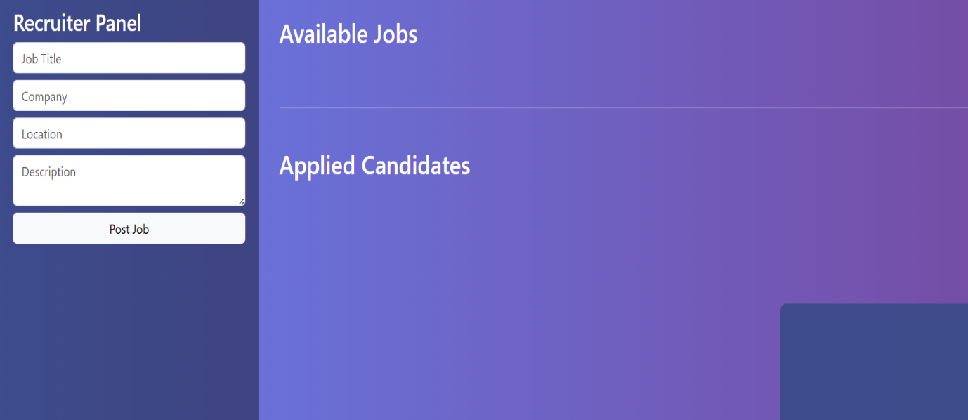
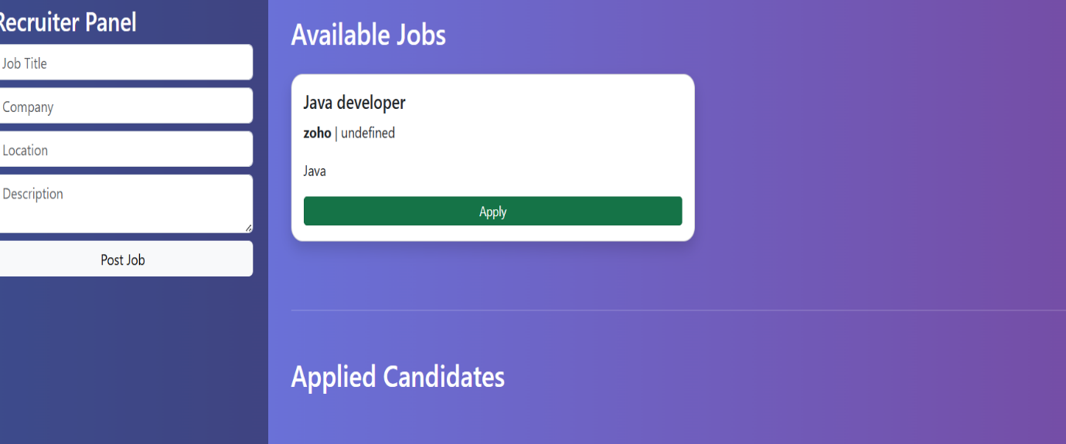

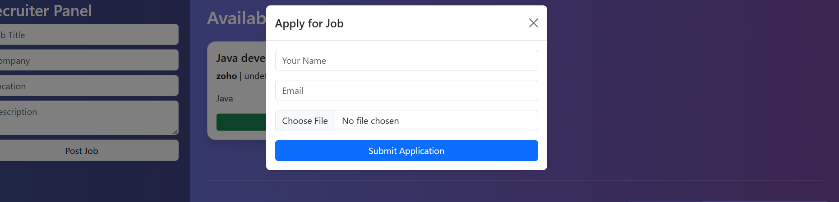
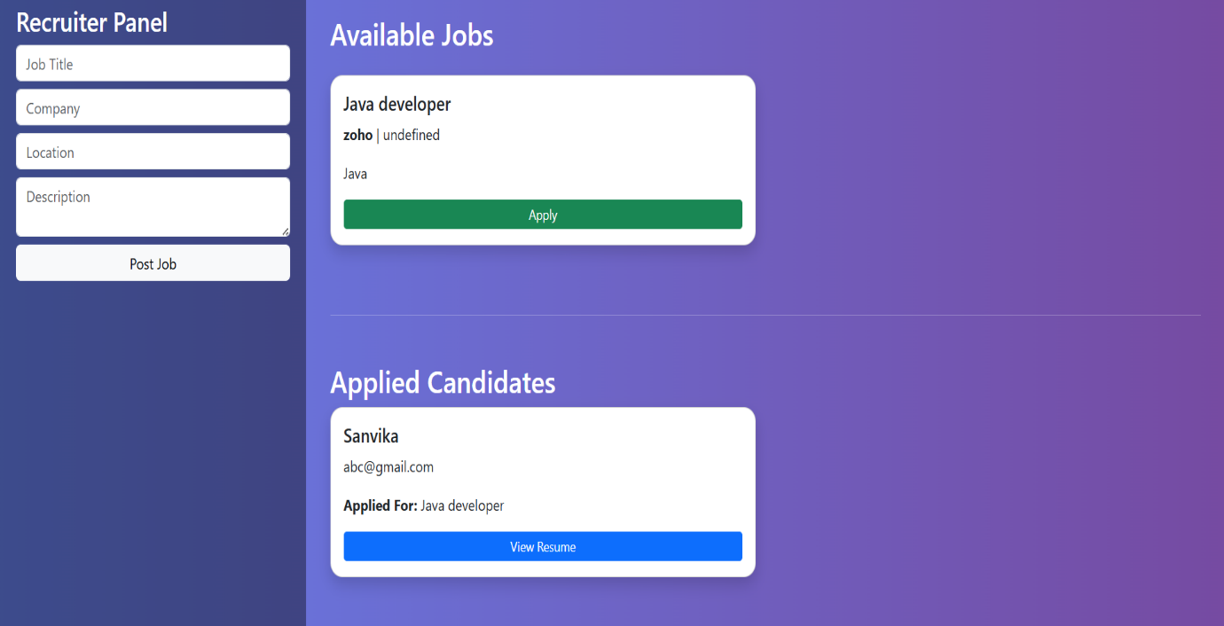

5.RESULT :
The Job Portal Management System was successfully developed. Recruiters can post jobs, and applicants can apply for jobs by submitting their details and resumes, which are stored and displayed on the system.

